**Lab Assignment 4**

**SQS:**

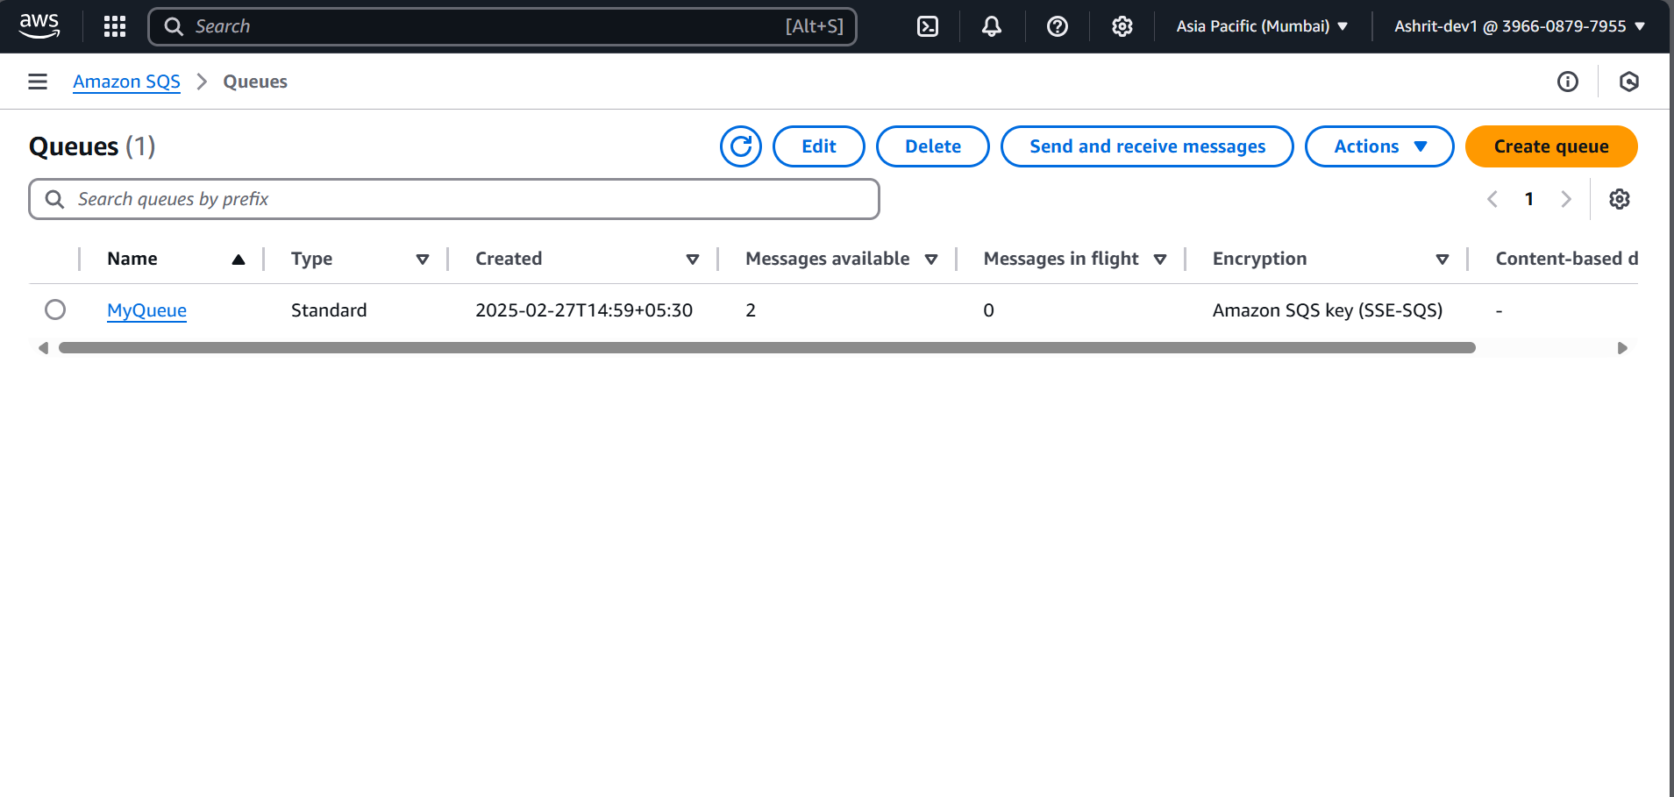

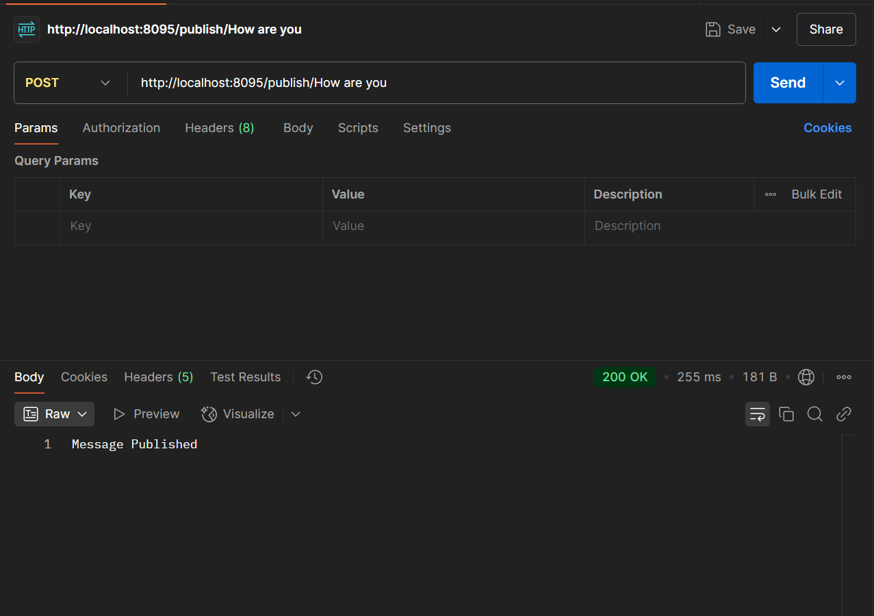

**SNS:**

